Guidelines for Itinerant Transnational Citizen Assemblies
Lessons from the Democratic Odyssey

Authors:
Irene Alonso, Camille Dobler, Andrea Gaiba, Ulrike Liebert, Niccolò Milanese, Kalypso Nicolaïdis, Christian Recchia.

A brief overview 1
Part I – Preparing the Assembly 6
1. Imaginaries and Initiation 6
2. Governance and Co-Design 8
3. Topic Selection and Thematic Architecture 10
4. Composition of the Assembly 14
5. Sortition and Recruitment 16
Part II – Running the Assembly 20
6. Formats and Spaces 20
7. Inclusive logistics and operations 23
8. Deliberation and Facilitation 27
9. Engage Emotions through Civic Arts 30
10. Integrate Expert and Citizen Knowledge 34
Part III - Embedding the Assembly 35
11 - Citizen Empowerment 35
12 - The public sphere 37
13 – Evaluation and Impact 41
14 – Institutionalisation and Political Buy-in 43
15 – Elected Representatives and Accountability 46

A brief overview

In recent years, a growing body of practical literature has emerged offering toolkits and guidelines on how to design and implement citizen assemblies.

These assemblies have become a cornerstone of democratic innovation, enabling randomly selected citizens to deliberate on complex issues and make collective recommendations. Yet, most of these assemblies remain defined by local, regional or national borders while most challenges we face today are transnational: from the climate crisis to migration, digital governance, and economic inequality.

There are few examples of Citizens' Assembles across borders, none of them institutionalised. Among these pioneering efforts are the Global Citizens’ Assembly on the Climate and COP (2023-26) or the Conference on the Future of Europe and its legacy including the Young Citizens Assembly on Pollinators (2026), and now routinised European Citizens Panels (since 2022). The field of transnational deliberation is an open space for experimentation.

The Democratic Odyssey is one such experiment and a first of its kind. Unlike traditional Citizens’ Assemblies, which operate within a single city, region or country, the Odyssey was itinerant, moving across three European cities to bring together a diverse group of members to deliberate on shared challenges. The assembly took place in Athens Florence and Vienna, as well as online throughout 2024-2025,piloting a new model of “translocal” citizen deliberation. Itbrought together citizens recruited locally in the host cities and others joining from across borders in a shared effort to test how democratic assembly processes can meaningfully operate beyond national borders yet without being confined to a single centre.

This moving format introduced unique challenges: logistical coordination, linguistic diversity, cultural mediation, and, not least, the absence of a formal political mandate. It offers a rare empirical foundation for understanding what it takes to design, run, and institutionalise itinerant transnational assemblies that are legitimate, inclusive, creative, and politically relevant.

What is a “Citizen Assembly”?
There are many ways of answering this question. Virtually all cultures and traditions have always practiced various forms of assembly. Whether spontaneous, protest-driven, or organised by institutions, assemblies bring people together to reflect and decide on shared concerns.

Since these guidelines focus on transnational citizen assemblies, we need to be aware of the cultural and institutional ‘conditioning’ that shapes how these spaces are designed and understood.

In their more structured deliberative form, citizen assemblies bring together a group of people, selected by sortition (random selection), to debate and negotiate solutions to a specific issue, either leading to recommendations or direct action. Sortition, which distinguishes citizen assemblies from other participatory formats, aims to ensure that those who participate mirror diversity of the broader population in terms of age, gender, education, geography, allowing the assembly to become a microcosm of society. Rather than relying solely on elected officials, citizen assemblies create inclusive spaces for all of us to learn about complex topics, exchange ideas and reason together before forming collective judgments. This process, canonically supported by facilitation and access to balanced information, builds a methodology and infrastructure that allows for reflection, representativeness and accountability.

The way citizen assemblies have been formalised in recent decades is deeply influenced by Western traditions of deliberative democracy. These traditions tend to value rational debate and discursive ideals that prioritise argument, evidence, and consensus-building through reasoned dialogue. While this model has been influential in advancing participatory and representative innovations, it can also limit how we imagine assemblies, sidelining more embodied, relational, or ritualised forms of collective decisionmaking found in other cultural contexts. In this sense, even the idea of ‘representation’ that underpins these assemblies, typically understood through numbers and social categories, is shaped by a specific worldview, rather than being universal.

These Guidelines bring together the core insights emerging from the Odyssey pilot assembly not as a literal account of how it unfolded, but as a reflection on the lessons learned through a trial-and-error approach. They are meant to be widely applicable around three main moments: (i) Preparing the Assembly; (ii) Running the Assembly; (iii) Embedding the Assembly. They are written from the perspective of a multi-disciplinary and transnational “crew” of researchers, civic actors, facilitators, cultural institutions, and elected representatives, acoalition of actors who believe that democracy must evolve alongside the realities it seeks to govern, realities that are interconnected and global. While the first (“Preparing”) and the second (“Running”) moments sequential, the third (“Embedding”) is understood to have an emphasis on the follow-up phase but includes meta-considerations about overall scaffolding.
Our fundamental lesson: transnational democracy is not simply a procedural innovation, but a cultural and relational project. Designing a transnational citizens’ assembly that moves across places requires not only robust sortition mechanisms and deliberative rules, but also care infrastructures, multilingual accessibility, diversity of engagement format, trust-building, and locally grounded partnerships. Running such an assembly demands multimodal facilitation, hybrid infrastructures, awareness of local political contexts, sensitivity to cross-border inequalities, and a commitment to transparency and reflection. Moreover, ensuring long-term impact requires embedding the assembly in the public sphere, securing institutional follow-up, nurturing citizen empowerment, and building alliances capable of generating political traction.
The Odyssey was only a pilot, its crew well aware of its imperfections and experimental nature, and the constraints imposed by a limited budget and the commitment to lowering the carbon footprint of transnational citizens’ assemblies. Within these constraints, the pilot demonstrated that transnational assemblies can foster genuine political agency. Participants who began unsure of their role came to see themselves as democratic actors whose voices matter-both locally and in Europe’s evolving political landscape. The assembly model tested does not replace elections or parliaments; rather, it complements representative institutions by creating new spaces for collective reasoning, mutual recognition, and cross-border solidarity.
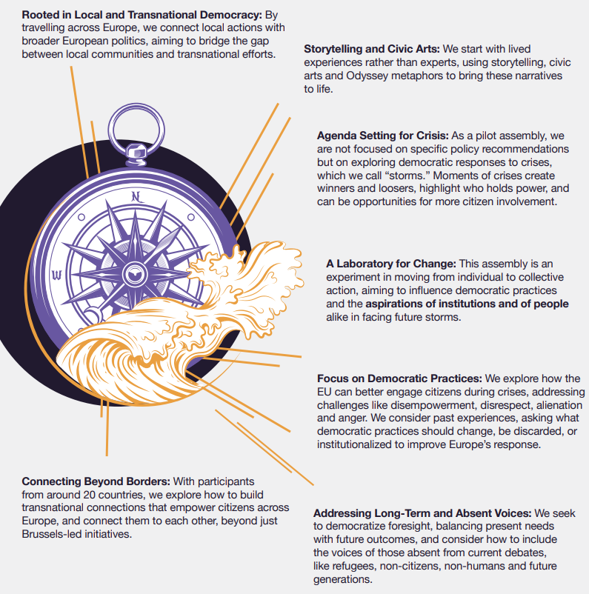
The Democratic Odyssey’s Compass
The guidelines collected in this document are the product of a crowdsourced methodological design. They have been inspired by the many members of the crew who have accompanied this journey, often on a volunteer basis. They have benefited from intense oral interactions with the assembly’s Constituent Network and are the result of written exchanges collected in a “Modular Framework” where plans and disagreements were regularly aired over the duration of the project.
Most importantly, these guidelines are not a fixed blueprint. They are living recommendations designed to support future organisers, municipalities, researchers, and institutions wishing to replicate or adapt the translocal Democratic Odyssey model. They offer a practical and conceptual foundation for a new generation of transnational citizen assemblies not only in Europe but across the world.
For other itinerant assemblies, the lesson is that movement must be purposeful and reciprocal. To travel democratically is to arrive as a guest, to listen before speaking, and to carry forward what has been heard so that each locality shapes the next, hence the need for ambassadors from place to place.
Two core ideas inspired Democratic Odyssey:
Transnationalism through Translocalism: At the heart of these guidelines lies a simple but transformative proposition: transnational processes and institutions like the EU and others will not become more democratic by erecting ever-higher institutional scaffolding from the top down, but by weaving denser civic and political relationships from the bottom up and across borders. Participatory democracy, in this view, should not take place mainly at the centre. It is to be not only a constitutional architecture but a lived practice, one that must be cultivated where people already encounter one another as neighbors, co-workers, migrants, students, parents, or simply citizens. This is the meaning of the guiding motto we propose for future assemblies that seek to emulate our approach: “Transnationalism through translocalism.” It reflects a philosophy of democratic change that rejects the false choice between the local and the supranational, insisting instead that democratic renewal must emerge from their mutual constitution.
Translocalism begins from a deceptively modest and hardly original insight: meaningful political agency grows from places, from neighborhoods, cities, towns, and regions, yet these places are never self-contained. They are nodal points in dense webs of interdependence: ecological, economic, cultural, digital, and political. As citizens in our assembly explored ways to democratise the management of crisis, this much became evident: To act locally today is already to act within a wider transnational field. Climate policies adopted by a municipality reverberate across supply chains. Migration debates in one city echo experiences elsewhere. Housing struggles, labor precarity, or cultural recognition are shared across borders. The Democratic Odyssey has taken this reality seriously. It treats local spaces not as parochial enclaves, but as entry points into planetary politics.
Translocalism through Itinerance: Our second guiding principle, “Translocalism through itinerance” captures the idea that democracy beyond the state is strengthened not by abstracting citizens from their places, but by moving political deliberation through those places, while bringing together citizens from these places and citizens from elsewhere. In the Democratic Odyssey, itinerance is not a logistical choice but a democratic method: the assembly travels from locality to locality, entering distinct civic ecosystems, listening to their histories, conflicts, and aspirations, and allowing each host community to shape the agenda. Translocalism, in turn, means that these local experiences are not sealed off from one another but are woven into a wider conversation across borders through which participants gradually expand their sense of “we.” Together, however, they model a form of demoicratic practice in which plural demoi remain rooted yet connected, and where collective intelligence emerges through circulation rather than centralization. “Translocalism through itinerance” thus proposes a different grammar of political community: not one people in one place, but many places offering hospitality and learning to recognize themselves in one another.

Part I – Preparing the Assembly

1. Imaginaries and Initiation

Democracy rests on participatory rituals and is invariably anchored in shared socio-political imaginaries. These imaginaries—often implicit—infuse every democratic act, shaping how citizens understand authority, legitimacy, community, and change. Transnational assemblies are no exception. The imaginaries they mobilise profoundly influence the kinds of debates that emerge about institutionalisation, permanence, and the mainstreaming of democratic innovation.
Engaging in the meta-journey of identifying these imaginaries while launching a deliberative process enables participants to situate their discussions within a wider horizon of meaning. It clarifies both the subjects who deliberate and the objects of deliberation, making explicit the visions of political community that underpin the process. At the same time, this reflective exercise helps reveal narrative gaps, tensions, or blind spots that require further exploration. Crucially, it strengthens the design of inclusion, making it easier to meaningfully integrate marginalised communities by ensuring that the assembly’s foundational imaginaries do not inadvertently exclude those it seeks to empower.
Principles
● The story of the assembly should appeal to widely shared social imaginaries
The choices that you make will be constrained by carbon footprint limits, budgets, human resources, timing and contexts. But within these, ask how they ought to inspire a long term sustainable process rather than a one-off event and appeal to a public as large as possible. The magic ingredients include at a minimum: An assembly size that conveys its geographical scope, a composition that celebrates the diversity of the publics at stake and a message (eg “Europe comes to town across towns”) that conveys its translocal nature.
An Odyssey Assembly Member stated:”I think it's very important to be a real Odyssey, to be not just physical, but also a kind of spiritual journey. … Because people always need a story to follow.”
● Put itinerance at the center of outreach
The images and realities of itinerancy across borders as a collective journey reflect the very ideal of shared ownership and distributed democracy. Itinerancy allows members to connect with multiple local publics and those publics to connect with each other, as different territories and communities host, interpret, and reshape the process according to their contexts. Itinerance may not be an easy proposition logistically but without it, transnational assemblies risk being divorced from local realities.
● Initiation is iterative
Each assembly cycle - and even each session in a cycle - renews and reinterprets the shared imaginaries. Mobilise images of travel and hospitality, for instance with rituals of arrival and departure, balancing the civic logic - clarifying the mandate - and experiential logic - celebrating the shared journey and repeated rituals of hospitality. This allows for a co-creative yet polycentric agenda setting, where priorities converge but do not cancel each other out. Participants must imagine throughout how their recommendations travel meaningfully, the potential pathways for uptake across different countries, and what forms of impact are realistic.
● Arts and language expand democratic imagination
Symbolic narratives, metaphors, and ritual practices shape meanings and break the technocratic mindset towards citizen engagement. Narrative design should complement - not obscure or crowd out - procedural transparency. Participatory arts and multilingual storytelling make deliberation emotionally accessible and culturally plural. These methodologies must be treated as a core process, not peripheral events or "entertainment." Every artistic activity (e.g. opening rituals, storytelling, participatory theatre) should be explicitly connected to the theme and objectives of the assembly. Crucially, collective debrief moments must follow each artistic intervention to embed the experience within the deliberative arc, ensuring that the "aesthetic experience" translates into "democratic insight."
● Embrace ‘meta deliberation’ on symbols and allow for structured improvisation
Co-created imaginaries cannot be entirely pre-planned. Planning should leave open, fertile space for the unexpected. Schedules must include "soft times" and open rituals that can host participants’ spontaneous energy. As noted in the pilot assembly, art is also a method of active listening. Early sessions (like onboarding) should utilize arts-based methods to cultivate active listening before moving to policy debate. Assembly members must be allowed to co-author not just the recommendations, but the rituals and framing themselves. Propose symbolic frameworks (songs, metaphors, artistic interventions) but explicitly empower the assembly to accept, reject, or modify them.
Tools
● Allocate resources for symbolic language and design (visual identity, metaphors, narrative arc, facilitators/ artists training).
● Use rituals of arrival, welcome, and departure to create continuity across cities.
● Embed artistic partners into facilitation teams from the start.
● Develop a Living Glossary of European Democracy to translate key metaphors across languages.
● Combine narrative design with clear rulebooks and facilitation protocols.
● Evaluate affective impact through ethnography, surveys, and creative feedback formats.

2. Governance and Co-Design
Transnational assemblies can follow different institutional logics. Some are primarily top-down, embedded within existing governance frameworks and structured around a consultative mandate, such as the European Citizens’ Panels. Others, while still institutionally anchored, grant participants a more direct agenda-setting or follow-up role, as illustrated by the Irish Citizens’ Assembly or the Permanent Citizens’ Dialogue in Ostbelgien. These formats typically arise from an institutional willingness to open the “black box” of governance, albeit within clearly defined remits, timelines, and constraints.
By contrast, transnational assemblies may emerge from the bottom up, initiated and facilitated by civil society actors and, at times, intertwined with broader social movements. In these cases, the ambition is not merely consultation but the generation of political momentum, the articulation of systemic grievances, and the formulation of transformative proposals, as seen in experiments like the Global Assembly.
The third path advanced by Democratic Odyssey seeks to bridge these vectors. It aims to combine institutional anchoring at both supranational and local level with broad societal mobilisation and public engagement, harnessing both the authority of institutions and the energy of civic movements. In this hybrid model, governance design is even more decisive. It shapes not only the process itself, but also who sets the agenda, who sits at the table, and who retains influence across the design, implementation, and follow-up phases
Principles
● Governance aspires to radical transparency and inclusivity

Whether or not formal institutions provide a mandate for the assembly, everyone must be able to see how decisions are made, by who and what resources are used. Transparency signals fairness, prevents perceptions of hidden agendas, and allows stakeholders from multiple countries to engage confidently with the process. Inclusion encourages mobilisation from unexpected spaces and actors, fulfilling the transformative power of participation and ensuring multi-actor, structural buy-in.

● Evaluation is embedded throughout

Participants, partners, and facilitators shape the process iteratively thanks to the feedback of independent observers (GLOCAN for the Democratic Odyssey). Under this ‘rolling evaluation’ principle, set up an independent network of observers as soon as possible, make all material available in full transparency and imagine constructive pathways to ensure feedback is itinerant and followed-up on throughout the process. Lack of receptiveness on this front often leads to serious and less traceable delegitimisation of the process, also hindering long-term normative assumptions about the potential of this specific democratic innovation.

● Local embeddedness and translocal governance anchors legitimacy

Assemblies should situate themselves within a wider ecosystem of democratic initiatives, fostering connections, learning, and synergies with other citizen-led or institutional processes. In particular, each city must host and interpret the process within its own political and municipal governance to the greatest extent possible connecting with existing participatory eco-system when they exist. Mutual learning on citizens’ engagement with sister cities strengthens translocal legitimacy and reflects the cross-border nature of transnational assemblies.

● Plan for follow-up and integration into broader democratic ecosystems

Transnational assemblies should design from the beginning clear follow-up mechanisms clear follow-up mechanisms both at the local level in terms of the legacy they leave in the cities they traveled to, and at the transnational level. These two levels of impact are a distinct feature of an itinerant transnational assembly. The follow-up mechanisms should include monitoring, reporting, and sustaining dialogue with members and stakeholders.
Tools
- Draft a short, public, revisable Governance Charter specifying roles, ethics, and co-design cycles. This should be as comprehensive as possible, and digitally available through a governance and process dashboard (making visible responsibilities, budgets, decisions, timelines).
- Use Action Plan frameworks to predefine responsibilities of institutions vs. citizens. Shared objectives should be Specific, Measurable, Achievable, Relevant, and Time-bound (SMART framework).
- Create supporting task forces for sortition, facilitation, public engagement and outreach, follow-up and more, according to the planned objectives.
- Form a translocal network of Local Committees in each host city to root deliberation in local civic culture and define a clear handover in itinernancy.
- Appoint a Unified Operational Lead for cross-city consistency, alongside rotating local partners.
- Establish a rotating transnational Citizens’ Steering Committee to monitor fairness and transparency.
- Establish an independent evaluation process to provide iterative and regular feedback during each step of the process and increase transparency.
- Provide fair labour conditions and paid-labour budgets for facilitators, coordinators and observers, especially if they act as evaluators.
- Invite elected representatives only to structured listening sessions and closing reflections.

3. Topic Selection and Thematic Architecture
Topic selection is one of the more crucial dimension of designing an assembly but offers greater challenges transnationally. Be ambitious about how much the ‘hive mind’ can be harnessed. A sufficiently broad and long-term topic can better mobilise translocal and intergenerational dialogue, tap into pre-existing public discourses and reframe emergency politics. For heavily institutionalised transnational deliberations, this may seem to come at the expense of governability of the process. Nevertheless, the positive impacts of opening the topic selection black box enables transformative contributions and widens support (or constructive criticism) from civil society and the general public at large.

A meta-community as enabler of futures’ thinking
We refer to other institutional models such as the Permanent Citizens’ Dialogue in Ostbelgien, where a permanent Citizens’ Council is empowered to decide topics but also has a limited number of assemblies that can be called upon each year. This incentivises for topics to be sufficiently ambitious and long-term and yet not disconnected from the political environment they are identified within. With the Democratic Odyssey pilot assembly, we deployed an adjacent model. The initial broad topic was selected by the Constituent Network, a meta-community of civil servants, politicians, civil society actors, practitioners, academics, citizens and ‘alumni citizens’ (i.e. citizens who have already taken part in previous assemblies at any level of governance). All took part in meta-deliberations concerning the assembly design and also selecting the topic of the next assembly cycle. The topic selected was chosen inter-alia for its adaptability across local contexts: “What needs to change for Europe to weather future storms? And how can we, the people, help better steer the ship?” It evolved into “How can crisis be managed more democratically?”

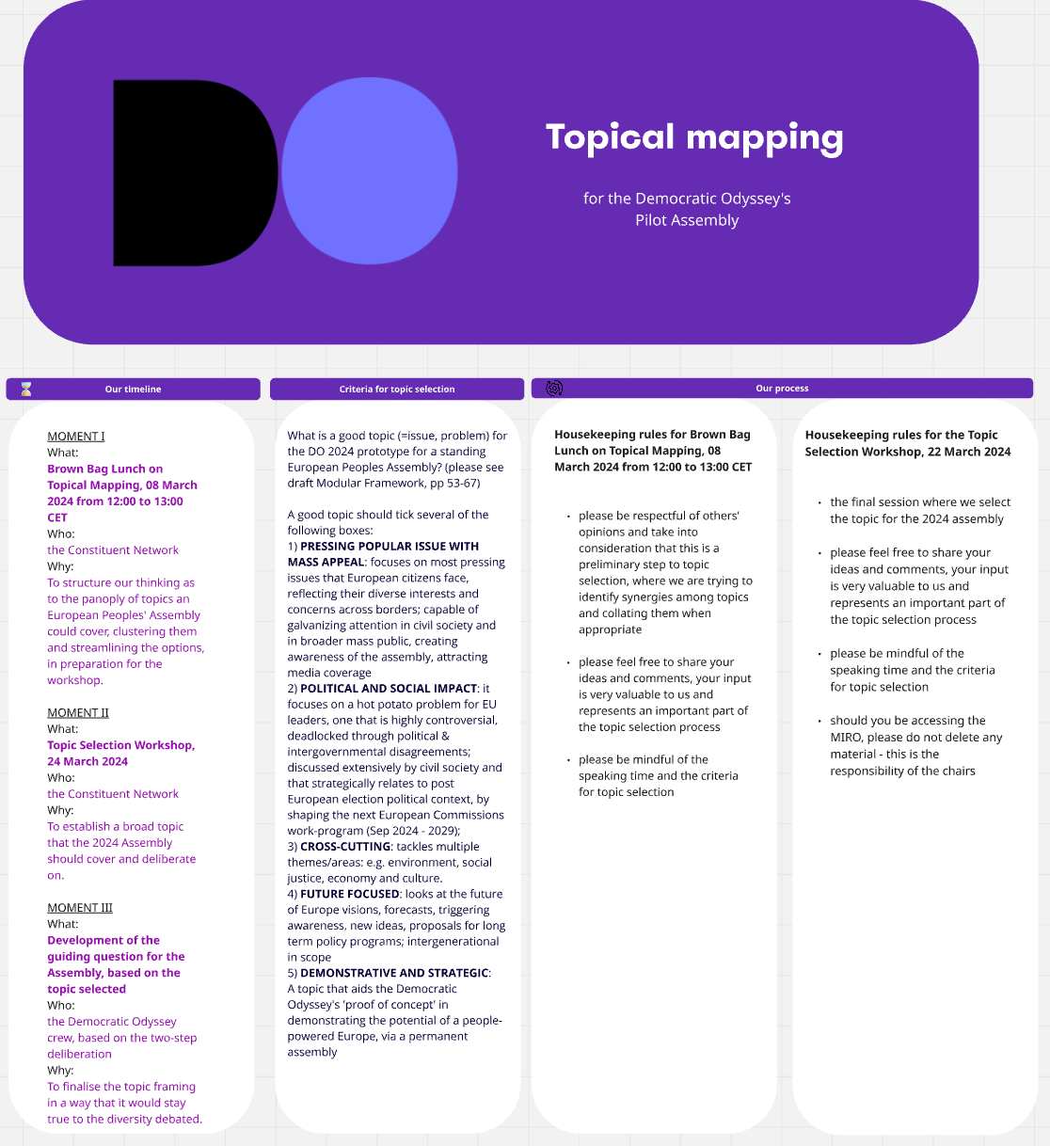
Source: The Topical Mapping’s timeline, workflow and scope, March 2024.

Principles
● The topic is deliberative and evolving
Make agenda-setting an integral part of the process, rather than a topic “set from above.” Transnational networks, or indeed the Assembly cycle prior to the one being initiated, can help shape an initial guiding question. The Assembly members own and fine-tune the question incrementally as the assembly unfolds, adapting to the changing political and historical environment.
The topic addressed by the DO assembly was generated by its Constituent Network and refined by the assembly members: how can we manage crisis more democratically?

As a testimony of the importance of crowdsourcing the topic, the pilot assembly foreshadowed by a year what later emerged from within the European Commission services as a European Citizens’ Panel on Preparedness.
● Narrative and experience matter
Lived experience, art, and storytelling help frame the remit of the topic and humanise complex topics that may be perceived very differently across borders. In doing so the facilitators should balance between breadth and depth through umbrella themes that allow cross-cutting insights with relevance across countries and cultural contexts. Sub-themes provide focus.
● Acknowledging that deliberation is inherently a political act
Uncover the underlying debates by spotlighting the core political conflicts and tradeoffs at play. If the topic also marks a significant argument for overlaps with crises of democratic governance, make these concerns available for further debate by accounting for the intersectionality of issues.
Tools
● Conduct pre-assembly citizen consultations in each country and language, and then across countries to co-design the guiding question.
● Use an “umbrella topic and sub-streams” model to combine coherence with depth.
● Integrate testimonies, local stories, and participatory arts in early sessions.
● Reconvene members periodically in between main sessions for topic review and recalibration.
● Combine citizen knowledge with multi-disciplinary expertise while preserving lay primacy.
● Maintain a transparent “topic evolution log” documenting shifts across cities.
● Use symbolic continuity - recurring rituals, metaphors, artefacts - to tie topic phases together.

4. Composition of the Assembly
The design of composition is inseparable from prior choices about imaginaries, modes of initiation, and the architecture of inclusive governance. At stake is a foundational question: how can a pluralistic vision of agency be empowered across borders? This requires thinking not only about descriptive representation through sortition, but equally about discursive representation, that is whose narratives, experiences, and claims are made present in the deliberative space.
At the same time, the field of deliberative democracy risks becoming overly self-referential, positioning assemblies as a technocratic corrective to the malaise of representative politics. Reconnecting with transnational democracy’s original aspiration to connecting people from different political cultures across borders helps restore the transformative potential of such processes. Expanding the pool from which participants are randomly selected operates as a participatory corrective, accelerating the interaction between transnational assemblies and other cross-border democratic instruments (as developed further in Part III).
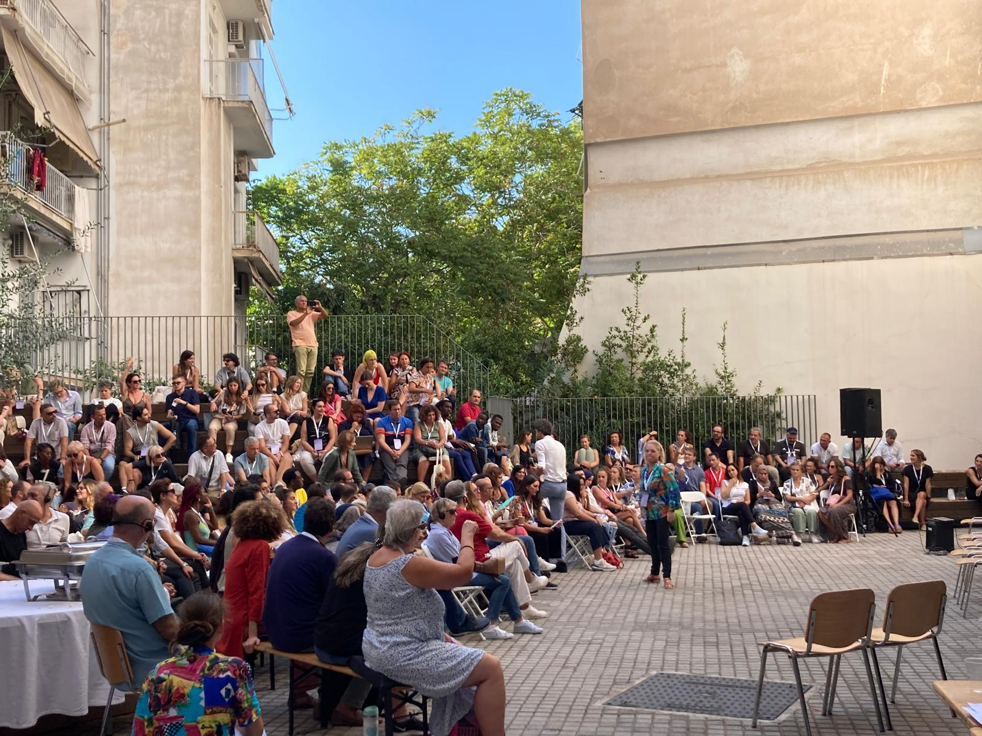
The Democratic Odyssey designed a methodology for identifying multiple pools of participants and this inspires the distinction between ‘sortition’ and the broader ‘ ‘composition’.

Principles
● Design to combine transnational and translocal composition shapes impact:
Cross-border representativeness traditionally means random selection across a number of countries. But the Assembly composition can be more ambitious and build on its itinerant character by combining members coming from the countries involved with local residents of the host city or country. Transnational members ensure that the assembly reflects as many national or local visions as possible while local members ground the vision in their shared locality and can help seed a follow-up. Local residents can also be chosen as non-local nationals who happen to live in the host city.
● Ensure continuity by combining online sessions for meeting of the whole assembly, with cross-border ambassadors
In order to build an Assembly that is larger than budgets or practicalities allow, the Assembly can combine itinerant physical or hybrid meetings where randomly selected members from prior meetings attend, with purely online Assembly meetings of the whole, all while the process is supported by reports and digital platform dialogues between meetings. This model allows all members to meet at least once with selected members and new cohorts joining on a rolling basis.
● Randomly selected assembly members can interact differently with different types of actors.
The inclusion of different kinds of actors can vary with the context. On one hand, civil society actors and organisations can constitute a separate pool of members per se, to the extent that they reflect a criterion in the same way as gender or socio-economics background. On the other hand, local or transnational elected representatives ought to engage with the Assembly, without becoming members. Their role is to listen, learn, and respond - not steer deliberation. Members serve the diversity of the assembly (e.g. bridges across countries), while interlocutors serve its engagement purpose.
Tools
● Use mixed composition: transnational sortition + translocal micro-selection.
● Publish selection criteria and diversity data in transparent formats.
● Invite assembly members to help refine future selection frameworks.
● Create a public “Map of the Assembly” infographic to visualise diversity.
● Include non-citizen residents and civic actors to reflect Europe’s actual demography.
● Evaluate perceived fairness and belonging through surveys and ethnography.
● Ensure local members are supported to lead or join follow-up initiatives.

Case Example: Partnering with Civil Society to reach refugees. The Democratic Odyssey & MetaDrasi (Greece)

Because the Democratic Odyssey wanted everyone affected by collective decisions to have a voice, it was crucial to reach refugees and people with lived experiences of displacement. In Athens, access to this community was not straightforward, as traditional sampling methods and registries do not include refugees. To bridge this gap, the Democratic Odyssey partnered with MetaDrasi - Action for Migration and Development, an organisation providing education and language courses for refugees in Greece. Through this collaboration, MetaDrasi reached out to its network to share information about the Assembly and invite participation. Thanks to them, 60 refugees applied, and 20 were selected to take part in the Assembly to whom we provided a stipend to recognise their time and contribution. Democracy can’t stop at the border of citizenship. When we work with organisations rooted in local communities, participation becomes more real, more inclusive, and closer to the world we want to build.
See: Composition, who is who in the Democratic Odyssey?

5. Sortition and Recruitment
Sortition is one of the key components of deliberative assemblies and the scaffolding bolstering input and process legitimacy. It is a mechanism aimed at ensuring descriptive representation and inclusion, doing away with a monolithic understanding of expertise and operationalising the ‘wisdom of crowds’. While there are best practices at subnational and national level, the key methodological questions regarding sortition and descriptive representation increase exponentially in the context of a transnational assembly. Selection criteria should always be fair, equitable, transparent and co-developed with an eye to best practices and structural inclusion.

Principles
● Go beyond demographic sortition
Random selection is the foundation of “collective” as opposed to “individual” representation, but inclusivity requires more than demographic representativeness. Sampling frameworks must reflect cross border heterogeneity and incorporate multiple demographic, cultural, linguistic, and political variables, recognizing the limitations of national datasets. Recruitment should also consider members’ motivation, worldviews, digital and technological access, and lived experiences relevant to the issues discussed. Value-based stratification reduces echo chambers and helps bridge cross-national differences.
● Engage civil society as “inclusion connectors”
Civil society organisations can help reach underrepresented groups, especially across borders, in ways that traditional sortition methods (door-knocking or phone calls) cannot do. Stratified random selection for the quotas from marginalised communities will still apply, but the methods in which the overall pool is expanded should be expanded to include civil society actors who know the local realities and how to mobilise community interest.
● Remove practical barriers to participation
Beyond recruitment and representation, inclusivity requires addressing the practical obstacles that can prevent people from taking part and are much greater across borders. This includes providing translation and interpretation for all languages spoken, stipends or financial support to cover travel, accommodation or lost income, childcare or family support, and visa or travel assistance for members crossing borders. In an itinerant assembly, local members can be encouraged to embody hospitality and help those arriving across borders.
Tools
● Use independent sortition bodies for neutrality and integrity.
● Include attitudinal diversity (e.g., trust in the EU, ideological variation).
● Provide multilingual, visual explanations (eg. “How We Were Chosen”).
● Use hybrid recruitment with public celebratory moments: macro-lotteries across Europe and micro-lotteries in each city.
● Comply with national and supranational data protection regulations
● Offer financial, logistical, and digital access support from invitation to participation.
● Livestream sortition ceremonies to enhance legitimacy.
● Track attrition and adapt outreach to fill representational gaps.
● Dedicate early sessions to discussing the meaning of sortition and democratic equality.
● Publish “Sortition Diaries” documenting lessons learned.
● Explore the creation of a European Sortition Agency as permanent infrastructure.
In the Democratic Odyssey pilot assembly, an Italian and a Ukrainian assembly member who both reside in Florence, talked about migration from very different perspectives. The Italian shared how migration affects their community. People often leave to find work elsewhere, and immigrants come looking for jobs. For the Italian assembli member, migration is about the economy and changes in their town. Conversely, the Ukrainian member had recently fled the Russian invasion and explained her perspectives on migration as a struggle for safety and the opportunity of a new start. They both spoke about the difficulties of leaving home and living in a new country. As they listened to each other, the Italian began to understand migration as more than just money or jobs, but rather people’s real struggles and hopes. The Ukrainian saw that migration often intersects other adjacent political discourses and can affect communities in different ways as a result. This also sparkled additional follow-up actions by these very participants, within the so-termed “Citizen Council”, i.e. the body autonomously governed by and for assembly members, responsible for ensuring follow-up. Local initiatives were kick-started after the assembly ended, focusing inter alia on engaging local communities and schools.
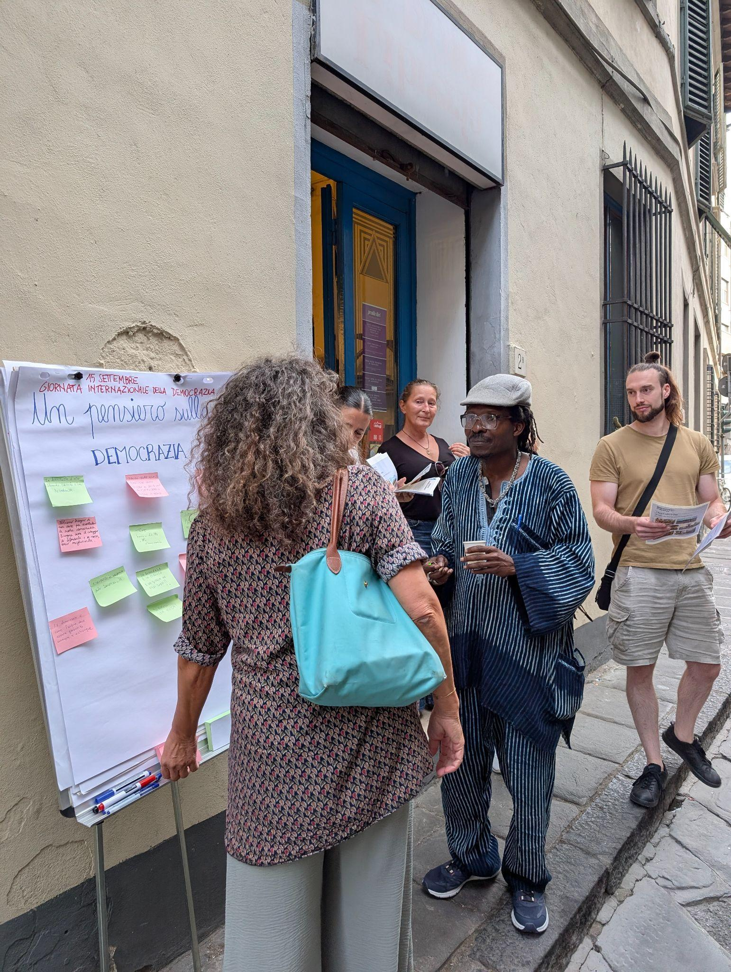

Part II – Running the Assembly

6. Formats and Spaces
Formats and spaces are the nuts and bolts of the deliberative process. They reflect the core imaginaries of the transnational assembly and set the scene for inclusive logistics and facilitation to actively engage with the surrounding environment. Planning the interaction between spaces and formats means designing for the experiential and emotional range available to assembly members who have left their familiar environments. These questions are incredibly interdisciplinary and range from facilitation to architectural insights, from cognitive psychology to political science, from events logistic to innovative ways of addressing diplomatic protocol. The overall format, which also connects with questions of governance and co-design, pave the way for the facilitation stream to generate epistemic quality.

The Democratic Odyssey’s participatory platform
The Democratic Odyssey digital platform is at the heart of sustaining transnational engagement. Designed to be more than a tool, the Odyssey platform is a living civic space. Based on the open source software Decidim, the platform allowed assembly members, observers, and the wider public to interact with the assembly process in multiple languages, breaking down barriers of geographical and cultural barriers. It served both as a repository and a space for further reflections and wider debates on the progress of the pilot assembly. The platform was also designed to offer a safe and private section for assembly members to connect, exchange among them and share material or additional questions and comments. Overall, the digital multilingualism proved to be a critical accelerator of the two meta-principles of the Democratic Odyssey: ‘transnationalism as translocalism’ and ‘translocalism through itinerance’.

Principles
● Translocal modularity writes a journey across spaces and their stories
Venues shape democratic meaning and provide emotional resonance, thus reflecting to the greatest extent possible plurality, imagination and local hospitality. Outdoor venues are more challenging but can be extremely meaningful. If possible, select venues that also allow for sufficient flexibility for both facilitation and civic acts to be deployed effectively.
● Venues should offer symbolic meanings to non-locals too
Imagine itinerancy can also be a journey through sites of democratic participation, whether with historical or contemporary symbolic meanings. Their stories should be told. If more symbolic venues come at the expense of ideal-type deliberation processes, imagine a sequence of venues that minimises carbon footprint, is logistically feasible, and offers a clear and inspiring narrative.
● Be attentive to cross-venue continuity
Continuity can be provided through various means including transnational members as well as “ambassadors” residing in each venue who attend sessions across venues, reports and artefacts providing a bridge between sessions, hybrid participation across spaces allowing all members to attend all sessions, digital platforms as virtual spaces available to all throughout the process while providing the main connection with the broader public.
Tools
● Hybrid infrastructures extend inclusion: Digital tools must be secure, interoperable, and accessible. Imagine constant interactions with a digital platform prior to and following hybrid deliberative moments.
● Develop welcoming rituals in symbolic venues: heritage sites, universities, civic centres, open public spaces.
● Develop welcoming rituals in symbolic venues: to harmonise deliberative processes and empower narrativisation by facilitators, plan brief guided tours of the venues and member-to-member, horizontal interactions between local and travelling members.

Los Cabildos Abiertos: Assemblies from below
In Latin America Assemblies can be convivial tools as well, spaces where people learn to live, think and act together. An assembly is not merely a decision-making mechanism but a space to enable participants to exercise autonomy, mutual care and collective imagination. The cabildos abiertos, are an example of that. They draw on a long Latin American tradition of popular assemblies, from indigenous community councils to neighborhood forums, where political participation is rooted in reciprocity and care. This convivial dimension was vividly present during the Chilean cabildos abiertos of 2019, when citizens gathered spontaneously across the country to reflect on inequality and envision a new constitution. In neighborhood plazas, schools, and cultural centres, people of all ages sat in circles, shared food, listened to one another’s experiences, and drafted collective proposals. What mattered was not only the conclusions reached, but the act of coming together across differences. Assemblies are living laboratories of democracy: spaces where trust, empathy, and belonging are practiced as political acts.

7. Inclusive logistics and operations
Developing a carefully constructed plan for logistical and operational inclusiveness is crucial to attain equal material conditions to the deliberation across borders. Such levelling-the-playing-field requires a wide range of transdisciplinary thinking and a structural approach. Mobility, accessibility and sustainability should be the core tenets of a transparent operational infrastructure. The transnational component requires specific features calling for reverse engineering from one locality to the next, and coordination across jurisdictions and socio-cultural environments. This may include stark variations in the time necessary to ensure logistical support of local partners.
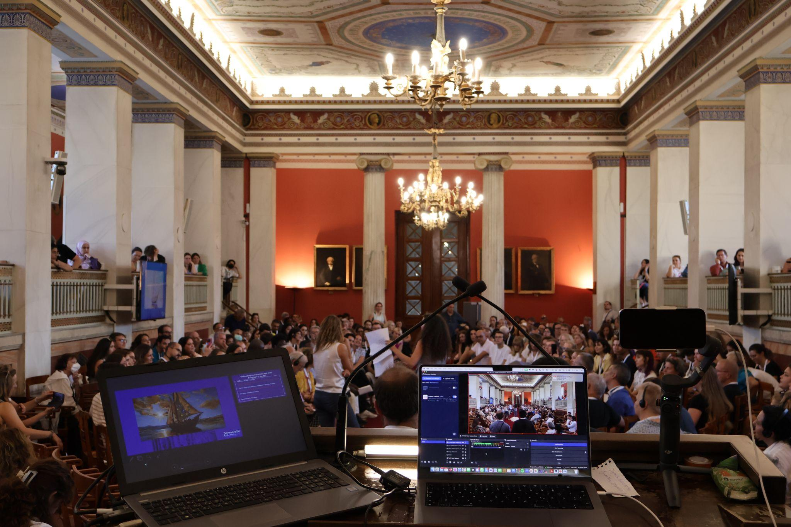
The Democratic Odyssey ensured all plenary sessions of the journey were livestreamed

Principles
● Strategic hosting
A transnational assembly that moves across countries creates additional logistical challenges. This can only be meaningful when its organisation is anchored in strong local partnerships, with civic actors, public institutions, and communities who hold relational and logistical knowledge. This local grounding provides continuity, legitimacy, and care to a process that otherwise risks becoming detached from place.

● Accessibility is a democratic norm
Every session must be linguistically and physically accessible. Crucially, accessibility includes physical accessibility of venues, provision of translation and interpretation services, digital access for remote participants, and dedicated accommodations for members with caregiving responsibilities, disabilities, or other specific needs.

● Intersectional care sustains participation.
Operational design begins with the recognition that emotional wellbeing is essential for deep deliberation and that members inhabit unequal worlds including when some travel and others do not. To make participation truly equitable, assemblies must build support systems, material, linguistic and emotional, that respond to these asymmetries. Cross-cultural empathy is not a soft skill but a structural principle: it means designing logistics, schedules, and modes of interaction that acknowledge vulnerability and difference as part of the political fabric, not as exceptions to be managed.

● Value-Based Budgeting and resourcefulness
In contexts of unstable or insufficient funding, empowerment requires resourcefulness - treating money, hospitality, trust, and solidarity as complementary democratic resources. When lacking the financial security of institutional backing, budgeting becomes a political act, one that reflects creativity and solidarity. Equity and collective responsibility rather than efficiency or profit.
Resourcefulness means recognising that money is not the only currency: partnerships, trust, and shared purpose are also forms of capital. Collaborating with local organisations, municipalities, and civil society networks can unlock infrastructures of hospitality and care, spaces, volunteers, interpreters, or meals, that would otherwise be inaccessible.

● Hybrid participation and digital inclusion
Transnational assemblies operate across vast distances, which makes hybrid participation not only a logistical solution but a democratic one. Blended physical and virtual formats allow more people to take part, follow the discussions, and witness the process, extending the assembly’s reach beyond those physically present. Facilitators and organisers must actively bridge the gap between in-person and online members, creating moments of interaction and shared ownership.
Tools
- Leverage in-kind resources: venues, meals, interpreters, volunteers, local cultural spaces.
- Include equity budget lines: stipends, care services, accessibility.
- Use participatory budgeting internally for selected cost categories.
- Establish a solidarity fund for members with significant financial constraints.
- Provide stipends covering time, not only travel, especially for working-class members.
- Ensure childcare, disability accommodations, mobility support, and fully accessible venues.
- Offer professional interpretation, translation, and digital access kits (headsets, hotspots).
- Design inclusive schedules that respect work and caregiving constraints.
- Establish a Literacy Program to address the respective gaps of:
○ Civic and political literacy on the part of citizens;
○ Deliberative literacy for policymakers and MEPs.
- Guarantee logistical equity: stipends, travel support, visa facilitation, full translation.
- Develop translocal modules: fewer international trips + strong local “nodes.”
- Advocate for a European Civic Visa enabling cross-border participation.
- Use interoperable hybrid platforms with multilingual interfaces.
- Prioritise sustainable travel, local catering, circular suppliers.
- Train hosts in inclusive, gender- and disability-sensitive logistics (“civic hospitality”).
- Choose venues that symbolise democratic plurality (parliaments, parks, universities, community centres).
- Treat logistics as pedagogy: document and explain logistical choices to members.
- Maintain horizontal coordination teams blending professionals and volunteers (“crew democracy”).
- Track costs, carbon footprint, inclusion metrics via a transparent dashboard.
This table provides an indicative overview of key budget categories unique to transnational assemblies:
Budget category | Description | Notes
Accommodation & Travel | Travel and lodging for members and organising team, including cross-border transport, visas, and travel insurance. | Essential to cover visa support and travel assistance for members from less privileged contexts.
Multilingual Translation & Interpretation | Simultaneous interpretation (in-person and online), document translation, captioning, and multilingual materials. | Crucial for inclusion and equal participation; requires experienced interpreters for multiple languages.
Technology & Hybrid Participation | Digital platforms, livestreaming, video conferencing licenses, IT support, hardware for virtual participation. | Ensures seamless integration of in-person and online members, including accessibility features.
Communication & Outreach | Multilingual outreach campaigns, recruitment, informational materials, and social media management. | Essential for reaching diverse and hard-to-reach communities across borders.
Catering & Meals | Food and refreshments considering diverse dietary needs | Include culturally sensitive options and support for members (e.g., meal vouchers).

8. Deliberation and Facilitation
An Assembly is a collective act of reasoning, imagination, and care both among the organising parties, as well as the facilitators and the assembly members. High-standard deliberation requires professional yet co-creative facilitation, ideally within multiple practitioners collaborating to tailor the design to a transnational assembly by tapping into their expertise and the diversity of participants. For transnational assemblies, cross-cultural sensitivity becomes exponentially critical, as are feedback mechanisms to improve from one session to the next. Plan for the facilitation workflow to connect as much as possible the public ecosystem of thought on the issues debated, while pinning the methodologies that enable breakthrough thinking. Within the assembly space - be it online or on site - practice active correction of asymmetries and inclusive prompting for quieter participants less familiar with multilinguism.

The Citizen Charter: Blending Onsite and Online deliberation
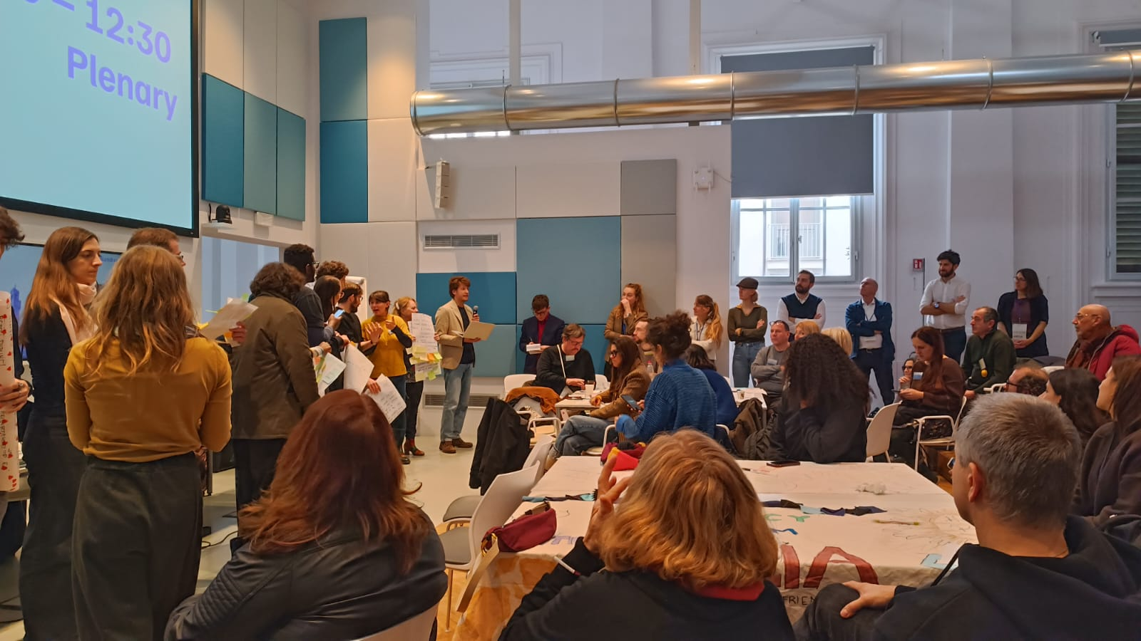During the final stage of the Democratic Odyssey in Vienna, participants worked collectively to draft what became known as the Citizen Charter, a text that distilled months of discussions, reflections, and encounters across borders. But this process did not happen only within the walls of the assembly. While participants deliberated in person, online participants and the general public alike, were all following the sessions live and engaging through the Democratic Odyssey platform with comments and proposed follow-up plans. In real time, they could read, comment, and suggest additions to the evolving text. This exercise required a strong logistical coordination by the organising team. This experiment in hybrid deliberation blurred the boundaries between physical and digital spaces, showing that transnational assemblies can nurture democratic participation across multiple layers of presence. The Citizen Charter was not the product of a single room, but of a distributed community.
Principles
● The deliberative journey best starts by taking members “from the I to the We”, to operationalise the spirit of hospitality
The journey “from the I to the We” can start with onboarding weeks for both transnational and local newcomers where exchanges best take place online in monolingual groups for ease of interaction. Each in-presence session can then start by putting in motion a Buddy System where local residents (nationals and non-nationals) welcome the travellers and serve as their “buddy” throughout the session and movement across the city. Participatory plays and exchanges of relevant experience ease the journey from “the I to the We” and into more formal deliberation.
● Navigate Linguistic and Cultural Diversity

Without translation, interpretation, and intercultural facilitation, participation is limited and inequitable. Language and culture shape who can speak and be heard. Diverse modes of translation can be combined from professional translation to whisper translation to tech-supported translation. But translation goes beyond converting words from one language to another: Translation is interpretive, cultural, and epistemic. It involves translating meanings, cultural references, assumptions, and norms so that participants from different backgrounds can fully understand and engage with the discussion.

● Attend to cross-border power and historical inequalities

Citizens from different countries tend to experience even greater different levels of privilege, mobility, and political and social recognition than within countries. Women, racialised minorities, refugees, and other marginalised groups are often disproportionately affected by these inequalities. They may face structural barriers to participation, including lower economic resources, limited access to information, social exclusion, or lack of recognition by formal institutions. Even when included in a transnational assembly, these participants can be overshadowed by more privileged voices if facilitation does not intentionally level the playing field. Facilitators must actively mediate these asymmetries.

● Recognise multiple ways of knowing across cultures

Multiple ways of knowing enrich transnational democracy and mediate cultural difference. Rational debate alone privileges Western-centric norms. Storytelling, embodied knowledge, and artistic methods complement rational argument. Deliberation must be multimodal, combining cognitive, emotional, artistic, and digital modes enhance inclusion. Clarifying the informational environment helps increase epistemic quality.

● Enable collective intelligence and inclusion of divergent voices

Once assembly members are at the table, the quality of deliberation depends on the dynamics of interaction. Facilitators must create a space where all voices, especially minorities, dissenting, and historically silenced perspectives, can be expressed, heard and considered alongside dominant ones. The goal is to harness the collective intelligence of the group, ensuring that diversity of perspective translates into deliberation outcomes that can be considered shared. Cross-border exchange of best practices could shift from informal alliances of practitioners to longer term visions for a European School for Democratic Facilitation for multilingual, cross-border training.

● Promote digital and hybrid inclusion

In person meetings are even more important in a transnational context. Nevertheless, cross-border itinerant assemblies are likely to rely in part on virtual participation. Ensuring fair access to digital tools and mitigating technological inequality is critical. Hybrid deliberation requires digital access, literacy, and methodological adaptation.

● Reflect and adapt continuously

The experimental nature of transnational assemblies demands flexibility. Facilitators must continuously adjust methods to context, participants, and emerging group dynamics. Deliberation is iterative and adaptive: Methods must evolve as group dynamics change.
Tools
● Use structured openings (“care and clarity”), check-ins, and reflective closures.
● Integrate interpreters as co-facilitators, not passive translators.
● Develop hybrid facilitation toolkits for online/offline/mixed formats.
● Provide facilitator training in non-verbal literacy, intercultural sensitivity, and trauma-aware practices.
● Combine analytical debate with embodied exercises, arts-based dialogue, and storytelling.
● Diversify facilitation teams across gender, language, and cultural background.
● Include wellbeing practices, group dynamics reflection, and emotional literacy.
● Dedicate time to deliberative reflexivity - reviewing facilitation, power dynamics, and inclusivity.
● Create a shared repository of session scripts, visual tools, and exercises (“Facilitation Commons”).

9. Engage Emotions through Civic Arts

Civic arts are not aesthetic embellishments but vital to deepening deliberation. Democratic life is experiential and affective whereby storytelling is key. Civic arts, including music, movement, drawing and theater is a quasi-universal language. The journey of the transnational assembly, including its itinerancy, can be made more meaningful by a wide range of civic arts that are openly presented to the participants as experimental and iteratively co-designed. In a transnational assembly space, strong emotions are often mobilised, particularly when important issues and trade-offs are explored. Subsequently, facilitators are responsible for ensuring that deliberation does not suppress emotions in favor consensus building. Civic arts offer shared language, one that does not need predominant translation in order to travel across borders. They enable the mutual recognition of affect. Simultaneously, they are also an exploration into the unknown thus also providing opportunities for discovery of the self.

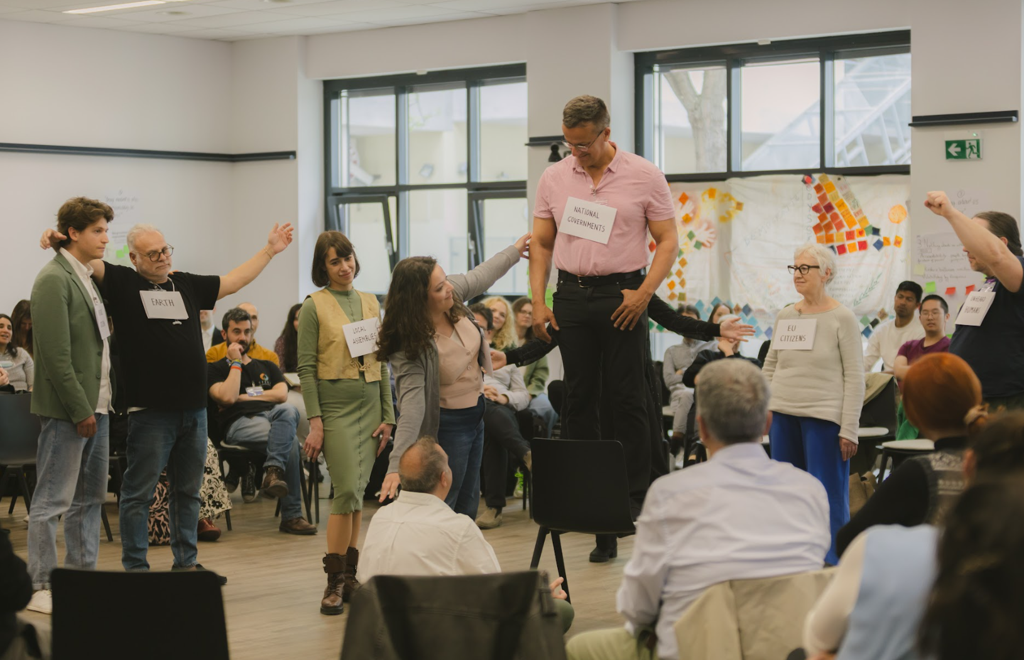
Assembly members of the Democratic Odyssey engage with the deliberative space through arts during the final meeting, in Vienna

Principles
● Develop an intentional framing for navigating the ‘mood cloud’
As a collective representation of societies' constructive and destructive moods, the ‘mood cloud’ conditions the Assembly's work. Pre-existing polarisation, amplified by misperceptions and digital echoes, can produce hostility and detachment, not in the juxtaposition between citizens and elites but within the group of citizens. Participatory arts are effective tools for diffusing these unspoken negative emotions and prejudices, provided they are introduced with radical clarity.
● Prioritize co-creation over pure artistic performance
Participants must understand the “why” behind an exercise. Art without a clear deliberative purpose risks alienating pragmatic participants. This principle is fundamental: shift resources from passive performances (spectatorship) to "generative arts," where citizens are the active agents in the tradition of forum theater. Co-creative acts, such as “Tableau Vivant” or role-play simulations transform the creative act into effective deliberation. Even performative arts used for symbolic framing ought to be conceived in a participatory way. If some assembly members seem ill at ease with civic arts activities, prepare a range of activities that can be adapted from one assembly moment to the next, based on live feedback. If necessary, intersperse the in-person sessions with digital ones, in order to make time to readjust activities - the assembly’s trust depends on it, as arts resonate at a deep level.
● Affective legitimacy is democratic legitimacy
Democracy is an experiential practice. Emotional connections enhance the authority and resonance of deliberative outcomes, generating "affective legitimacy". Designs must engage bodies, narratives, and collective self-regulation. Artistic engagement, such as “Tableaux Vivants”,enhance empathy and collective imagination and must be integrated into the deliberation process (not just "during the break"). One person needs to be tasked with listening to grievances and hopes of the participants, manage the complex emotional loads generated by the assembly.
● Itinerancy can help participants feel ‘at home abroad’ through lived hospitality
Itinerancy, despite being logistically demanding, is essential to the sense of belonging. Use participatory arts to imbue the journey with deeper meaning, promoting "lived hospitality" and transnational belonging. Methods like “Playback Theatre” or the "buddy system", accompanied by local welcome stories can strengthen cohesion. Simultaneously, the use of travelling symbolic artifacts (like the Odyssey's sails) is crucial for conveying continuity across borders and sessions.
In the Democratic Odyssey Imagination inspired by the shared story of navigation helped navigate deliberative journeys
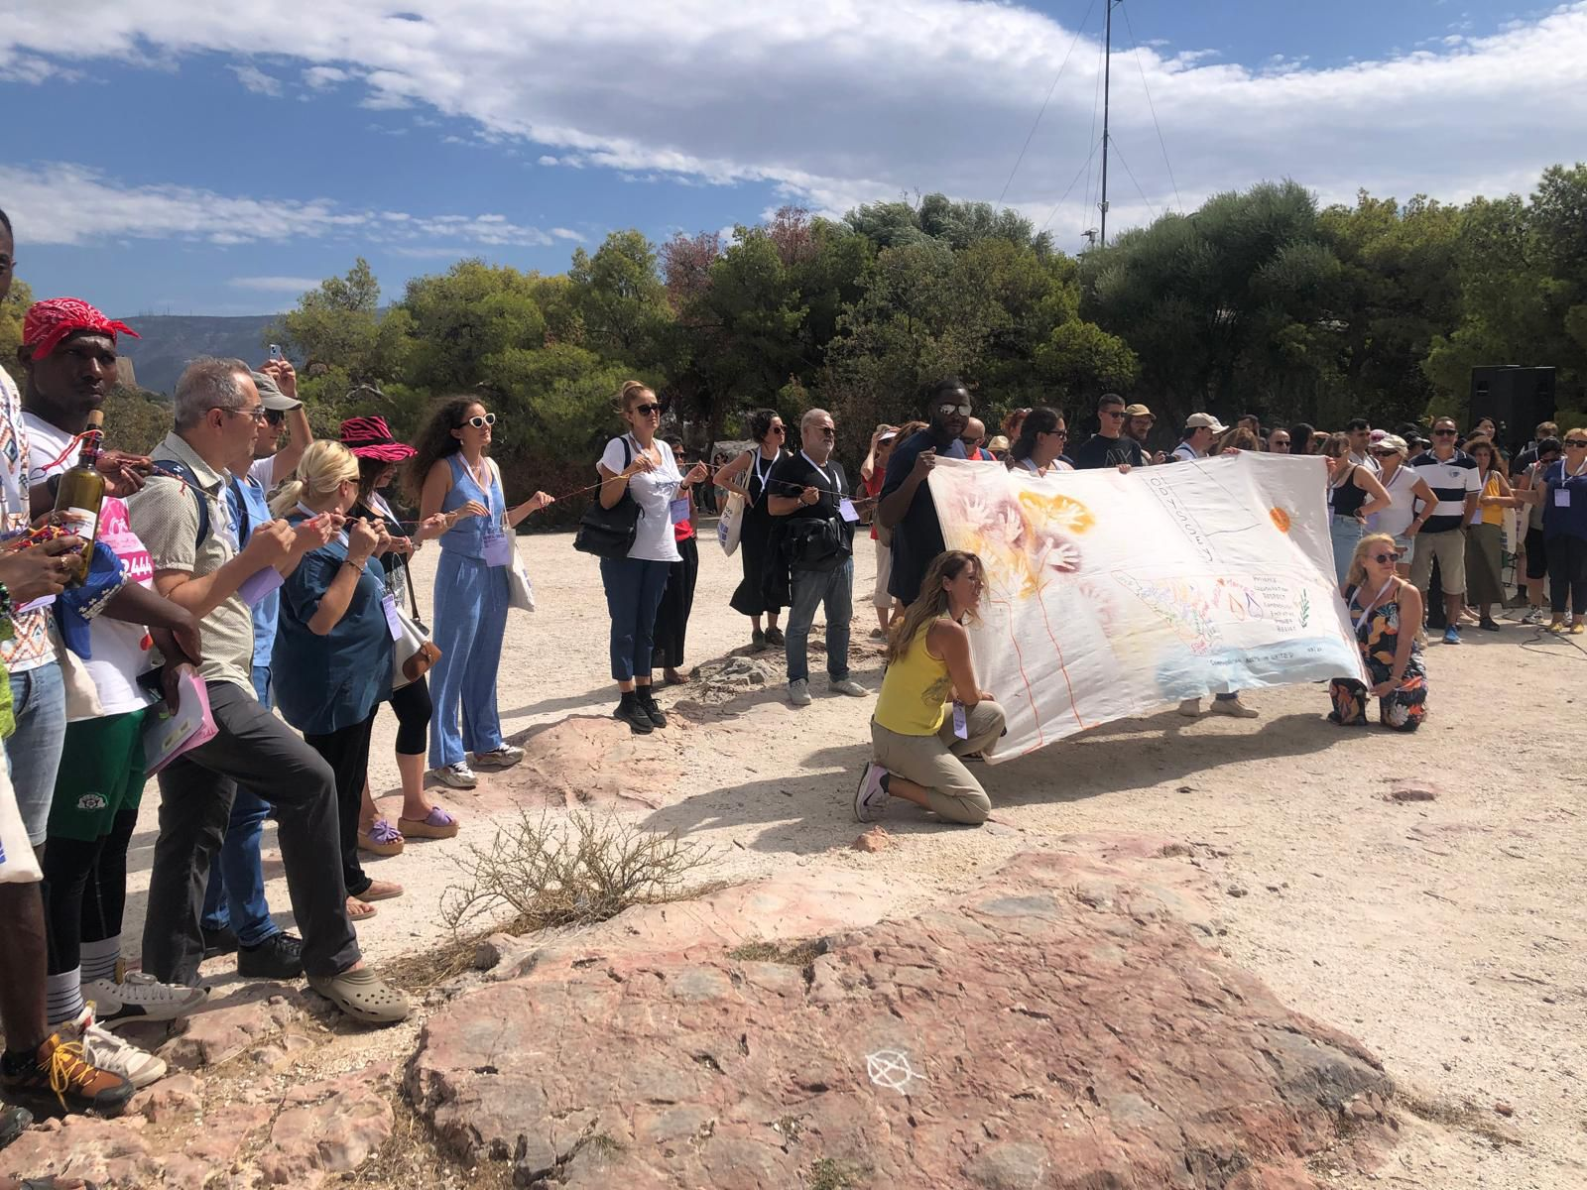
Each Assembly must develop its own narrative arc to frame the deliberative journey. The Democratic Odyssey utilized the metaphors navigation and Greek mythology to access deeper emotional circuits and familar stories. Member travelled through Seas and Rivers in welcoming performances, songs, messages in bottles and sails. Mythic frames allowed deliberation to surface emotion through imagination, not just rational argument. This process transformed deliberation into an act that was both rational and mythopoetic - a modern ritual of re-storying collective identity.
● Embed assemblies locally through public cultural events
To increase local visibility, civic joy and the likelihood of democratic follow-up, the Assembly’s presence in a city or region should be accompanied by local public cultural events (such as festivals). This strategy helps both for Assembly members to experience local belonging, and local residents to experience the Assembly's arrival as an event of civic relevance.
● Art can be included with an eye to “whole society” relevance
Artistic integration contributes to cultivating an emotional attachment to democratic practices and rules, allowing citizens to perceive themselves as capable civic agents, not mere spectators. The goal is to contribute to improving democratic practices in the cultural, emotional, and normative fabric of society, strengthening a minimal democratic ethos of freedom, mutual respect, and solidarity.
● Professionalization and Sustainability
The successful integration of these methods requires a dedicated budget and professional resources to ensure quality and sustainability. We recommend the inclusion of professional "art mediators" as well as provision of specialized training for facilitators in aesthetic literacy. Facilitators must be equipped to manage the vulnerability that methods like immersive democratic theater evoke, ensuring spaces remain “safe but brave”.
Tools
● Integrate spatial and artistic design as core infrastructure, not decoration.
● Prioritize co-creation over performance.
● Rotate assembly locations across diverse regions (“symbolic itinerancy”).
● Train facilitators in aesthetic literacy to use space and art pedagogically.
● Involve artists as co-designers from project inception.
● Establish guidelines for ethical emotional facilitation.
● Choose inclusive, accessible, light-filled venues reflecting democratic values.
● Use shared artefacts (sails, flags, collective artworks) as travelling symbols.
● Evaluate emotional and artistic impact via surveys, diaries, and ethnography.
● Recognise emotional connection as a key measure of legitimacy.

10. Integrate Expert and Citizen Knowledge
Collective intelligence is the beating heart of participatory democracy. Its primary source is the knowledge, skills and experience of citizens themselves. How do we translate this insight into action?
Principles
● Adopt a non-hierarchical relationship between citizen and expert knowledge
Anchoring the facilitation journey in the lived experiences of participants rather than abstract expertise is a golden key to unlock “connections” across different nationalities. Facilitators need to find ways of drawing out “life as experience” before bringing in “experts”. The experts can be introduced as respondents, aggregators and analysts rather than authorities from above. They can react to rather than preempt the knowledge shared by the members of the assembly. Citizens are authors, not recipients: Outputs must be written by members, supported but not overshadowed by experts.
● Outputs can be be multi-layered, open and evolving
Knowledge is a commons. Expertise must be plural and transparent: technical, lived, and deliberative expertise all matter, and must be disclosed and contextualised. A charter or set of recommendations emerging from an assembly requires explanatory depth to demonstrate rigour and richness. Therefore data, testimonies, and materials that have led to the outputs should remain openly accessible and open. As such outputs should be living documents, with the possibility of being updated and built upon by future assemblies.
● Introduce a "Global Mirror" component
To counteract Eurocentrism and complacency, future assemblies should formally include a "global mirror" mechanism. This requires inviting speakers or observers from non-European and even non-democratic contexts to reflect on the European process from the outside. This comparative perspective serves a dual function: it highlights the global privilege of democratic freedom and provides more nuanced discourse around different positionalities.

“ Our Charter should not be a static document [...], but it should be open for changes. Because time changes and people change." A member of the People’s Council of the democratic Odyssey
Tools
● Combine technical, experiential, and deliberative expertise through structured protocols.
● Require experts to disclose assumptions, uncertainties, and alternative views.
● Replace lectures with interactive exchanges and small-group dialogues.
● Train facilitators as knowledge mediators bridging expert–citizen vocabularies.
● Ensure citizen authorship of final texts; experts should advise, not draft.
● Publish a Substantive Addendum with minutes, arguments, and evidence supporting recommendations.
● Present outputs in multiple modalities (reports, videos, artistic forms).
● Establish a “European Knowledge Commons” for open access to data and documentation.
● Treat the Charter as a living document open to periodic revision.
● Build structured follow-up channels with EU institutions to discuss uptake.

Part III - Embedding the Assembly

11 - Citizen Empowerment
The ideal of citizen empowerment may be the powerhouse of transformative change in our democratic societies but cannot easily be tracked with such things as key performance indicators. It is frustratingly iterative, subtle and amorphous. By connecting with pre-existing activities on the ground, a translocal assembly can foster a sense of shared empowerment through horizontal connection rather than simply vertical access to power.
Principles
● Empowerment unfolds across time and space
Empowerment does not end at the place and time of the assembly. It becomes real and contagious when citizens have ongoing opportunities, institutional recognition, and pathways for continued engagement, through mutual empowerment across democratic experiments. Citizens will feel co-governors of a transnational democratic ecosystem if they are treated as continuous democratic actors, with opportunities to continue the journey if they so wish, all while mentoring their successors
● Plant democratic seeds by turning rotating hosting into local empowerment
Transnational assemblies empower citizens when they are rooted in local contexts and travel across territories. Geographical rotation expresses shared ownership, while strong local partnerships ensure continuity beyond the Assembly sessions themselves as members can partner with other actors to plant new local democratic seeds or help grow existing ones. Empowerment grows through relationships, across borders, sectors, and communities. Collaboration distributes agency and builds trust in a shared democratic process.
● Design universal and inclusive accessibility to empower future participants.
Citizens can only be empowered if they can participate meaningfully through accessible means. Physical, linguistic, digital, financial is a democratic requirement, not an optional feature. Learning from the obstacles and the solutions it encounters in different spaces and localities, a transnational assembly can serve as a learning space for future accessibility.
● Make hybrid and digital participation exciting
Empowerment requires making physical and virtual presence equally meaningful since digital and hybrid formats expand participation and visibility especially across borders when travel may not be carbon-compatible and affordable. But hybridity needs to be thought through on its own terms, not as a mere window on in-presence events.
● Transnational empowerment starts with mutual recognition
Empowerment is bolstered in a transnational context if members feel recognised by peers from different countries including through the local-traveller encounter. It spans to the commitment to shared social goals, a rekindled sense of belonging that does not stop at borders, engagement with our legitimate differences.
Tools
● Integrate hybrid methods from the start (not as fallback).
● Design specific facilitation to connect online and onsite participants.
● Provide digital literacy support and platform training for all attendees.
● Livestream plenaries to broaden the democratic audience and ensure transparency.
● Use co-design workshops with civic organisations, universities, and public bodies.
● Develop a shared partnership charter clarifying roles, commitments, and values.
● Integrate former members into planning teams to sustain relational continuity.
● Adopt rotating facilitation teams to democratise internal decision-making.
● Establish post-assembly mentoring and micro-grant schemes for citizen-led initiatives.
● Develop a Citizens’ Council (or equivalent) to track follow-up and ensure accountability.
● Conduct follow-up touchpoints (6 months, 12 months, 24 months).
● Invite members to future events, training, and translocal projects.
● Use well-being indicators in evaluation (belonging, recognition, confidence).
● Provide trained emotional support or mediators for challenging moments.
● Formalise institutional pathways for responding to recommendations at local/EU level.
● Involve citizens in co-designing future assemblies or thematic cycles.
● Create a European Citizens’ Alumni Network for peer learning and ambassadorship.
● Amplify citizen presence through public events, artistic documentation, and media engagement.

12 - The public sphere
The idea of ‘mini-public’ as a sanitised and perfectly deliberative stand-alone microcosmos of the broader public sphere is unrealistic. The sea of democracy is messy, has many current and undercurrents, many unforeseen companions and dangers. Connecting with the society at large is perhaps the greatest challenge facing an assembly. In the transnational context, this means connecting with different albeit interconnected public spheres and different political, media and linguistic cultures.

The Festivals Anchoring Assemblies in Local Contexts and Expanding Participation

Within the Democratic Odyssey journey, in each assembly we created festivals with unique themes to both anchor the events in their local context and engage people who were not directly participating in the assemblies. We opened doors not only for deliberation but for celebration. These were moments where art, performance, and civic imagination intertwined, inviting everyone to step into the world of democratic experimentation. In Florence we organised ‘the village for civic action’, featuring a documentary, talks, performances, and spaces for organizations working with young people and democracy to engage the public. The festival became a hub for interaction and reflection, connecting assembly participants with broader civic actors. In Vienna, in partnership with Festwochen, we imagined ‘Democracy as an Act of love’, a festival of games and encounters with social movements. It celebrated the many experiments across the city that seek to transform political life, reminding everyone that democracy is also joy, imagination and care. Through these festivals, outreach becomes embodied and visible. They are our way of creating spaces where citizens can touch, feel, and participate in democracy. Assemblies must build community and open the possibilities of democratic innovation to everyone.

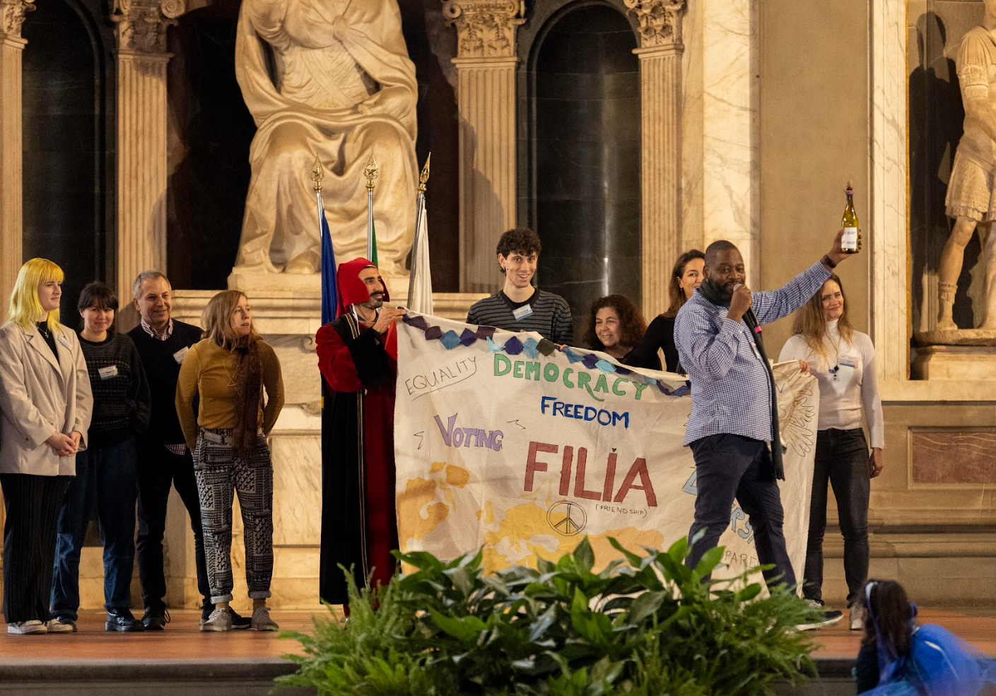
Principles
● Nurture translocal narrative framing as democratic infrastructure

How we communicate the process matters as much as the process itself. For an Assembly to exist in a very noisy public sphere is all the more difficult if transnational. Throw all the energy and technologies you can at the challenge by prioritising public outreach, resonance, and impact early on. Make the communication strategy a co-creation endeavour with key stakeholders to maximise impact. Assemblies must be communicated not as isolated experiments but as part of a wider trajectory of democratic renewal that can connect places and peoples. A strong, shared narrative helps publics situate the assembly within ongoing social and political change.
- Bring together local partners, transnational media, and civic alliances as co-authors
Public sphere engagement is most powerful when it is authentic and participatory. Citizens should appear not only as subjects of communication but as co-authors of democratic meaning through polycentric engagement of both local and transnational partners while engineering dialogues between them. Embedding assemblies in public debates across countries requires alliances with media, cultural institutions, and civil society networks. Transparent communication through livestreams, documentation, and archives, ensures assemblies remain open, accountable, and publicly accessible. But accessibility does not guarantee publicness. Assemblies gain relevance when the broader public can interact with them through various feedback loops, by commenting, proposing, or following up through digital platforms, meetings, or social media. .
- Build a transnational community for the long term
Transnational assemblies require more than coordination across locations, they need community. To reach a broader public these communities can be designed to grow over time, sustain momentum, and create a collective memory of democratic learning. Communication and outreach should nurture spaces where participants, facilitators and observers remain in dialogue across borders after the assembly. Communication strategies must be long-term, linking phases of learning, deliberation and reflection.
The Democratic Odyssey is sustained beyond the pilot assembly by its European People’s Council, randomly selected at the end of the assembly. Its task is to support ex-post campaigning and hold institutional actors accountable. Recognition of its consultative powers ensures continuity and democratic oversight beyond each assembly cycle.

● Take multilingualism in public outreach seriously
English tends to be the transnational language in Europe and beyond, especially in contexts with low budgets. But this reality should not prevent multilingual communications units to be embedded into the assembly structure from the outset. To achieve this with low budgets, assemblies can operate within hybrid public spheres that combine online spaces with automatic translation, and in-presence spaces with whisper and informal translation. As the use of AI for translation becomes ubiquitous, attention should be paid to its side effects.
● Maximise inclusion of diverse audiences
Public sphere engagement must be as accessible as possible to a wide range of people, with special attention to exclusion due to language, disability, or digital divides. In particular, responsible and inclusive use of digital tools calls for creative use of social apps. Online tools complement, rather than replace, embodied public deliberation. Media should be mobilised as soon as possible by offering spaces and opportunities to actively participate in the experiment.

Tools
● Organise public forums, Q&A sessions, and community dialogues during assembly cycles.
● Enable moderated comment channels across social media and the assembly website.
● Develop a transnational communications hub for updates, exchanges, and peer learning.
● Facilitate cross-border alumni dialogues, newsletters, and virtual meetups.
● Create shared digital spaces (forums, groups) linking members, facilitators, observers.
● Maintain communication between cycles through newsletters, podcasts, and updates.
● Anchor communications in an ongoing strategy rather than event-based announcements.
● Create a dedicated multilingual communication team.
● Integrate communication planning into agenda-setting and logistical design.
● Use festivals, artistic interventions, and public exhibitions to anchor assemblies locally.
● Equip each host city with communication toolkits and autonomy to adapt messaging.
● Encourage municipalities, cultural institutions, and NGOs to use their own networks.
● Coordinate local outputs into a shared pan-European communication stream.
● Partner with European broadcasters, cultural institutes, and independent media.
● Use stakeholder mapping to engage diverse and non-traditional media channels.
● Develop cross-border media collaborations that follow the assembly from city to city.
● Safeguard privacy, accessibility, and data ethics.
● Offer digital literacy support for members and publics with limited digital access.
● Provide interpretation, captioning, sign language, and plain-language summaries to digital content
● Regularly assess accessibility barriers and adjust communication strategies.
● Develop indicators for audience reach, media resonance, and engagement quality.
● Track perception shifts through surveys, interviews, and media analysis.
● For Citizen-Led Content & Co-Creation Integrate citizen testimonies, members-created media, and co-produced content. Avoid over-curated or overly polished communication that erodes trust.
● Co-host events with local actors, allowing publics to shape themes and formats.

13 – Evaluation and Impact

Observers and evaluators are key actors in this story to guarantee the quality and integrity of the process as well as its replicability. Crucially, they provide accountability and therefore credibility to the process.

Principles
● Reflexive evaluation as integral process design
Evaluation must be embedded in the process from the very beginning rather than added after the fact. It can provide precious feedback at the end or better, on an ongoing basis throughout the entire process. Real-time adaptive adjustment allows the steering crew to adjust the process as it unfolds and ensures both methodological rigour and democratic ownership.
● Multidimensional impact metrics
Impact assessment ought to reflect the multi-layered nature of the Assembly, spanning cognitive, emotional, civic, institutional, and symbolic dimensions. Evaluation tools need to work across multiple national, cultural, linguistic and disciplinary perspectives while capturing local specificities. They may choose to focus on one or all of three types of legitimacy: i) input legitimacy (who is in the room, how they were selected, and how inclusive the process is); ii) process legitimacy - the quality of deliberation and interactions) and iii) output legitimacy (the quality, coherence, and influence of recommendations and outcomes).
● Mixed-Method evaluation
No single method captures deliberative impact. Quantitative and qualitative tools must be combined to reflect complexity. A transnational assembly at its best will help reshape democratic imagination. Evaluations must capture symbolic effects, not just procedural outcomes.

● Longitudinal tracking and diffusion analysis
Impact unfolds over time. Evaluations must follow participants, institutions, and networks beyond the assembly itself. Evaluation will likely contribute to democratic accountability only when results are visible, accessible, and understandable to the public.

● Linking Evaluation to Institutional Uptake
Evaluation is most useful if it feeds into real political or societal practices. Findings should guide institutional follow-up, reform, and accountability.
● Ensuring Ethical and Inclusive Evaluation
Evaluation must also avoid reproducing inequalities. Ethical safeguards and inclusive methods are essential.

● Public Co-Evaluation and Participatory Review
Evaluation can model democratic practice by including citizens and publics in assessment to strengthen ownership and legitimacy.

● Towards a European Agency for Participatory Democracy

Sustainable and independent evaluation could be much enhanced through a permanent transnational infrastructure that collects, compares, and disseminates data at scale. At the European level, these competences would be well-nested in the Joint Research Centre’s Competence Centre on Participatory and Deliberative Democracy, in collaboration with a rotating roster of official observers.
Tools:
● Form an Academic Evaluation Team (deliberative quality, representativeness, communication reach)·
● Facilitate a Citizen Learning Circle reflecting after each session.
● Facilitate a Partner Feedback Network (facilitators, hosts, civil society
● observers).
● Define feedback loops at each phase (before, during, after).
● Use evaluation for continuous improvement, not only final assessment.
● Track changes in learning, trust, confidence, empowerment, and civic skills.
● Measure deliberative quality, inclusiveness, and discursive transformation.
● Monitor institutional uptake and the visibility of recommendations.
● Develop survey templates adaptable to multiple languages, including entry and exist surveys
● Use standardised observation grids and core indicators with space for local additions.
● Train evaluators and facilitators to ensure consistent coding and interpretation.
● Follow participants’ civic trajectories at 6–12–24 months.
● Track spin-off initiatives, community projects, and Citizens’ Council activities.
● Assess narrative diffusion across media, institutions, and local territories.
● Hold meta-deliberation sessions for collective reflection on process quality.
● Present evaluation reports to EU institutions, national parliaments, and local governments.
● Translate insights into actionable recommendations for institutional reform.
● Secure informed consent and protect privacy across languages and contexts.
● Use citizen review panels to assess process quality and recommendations.
● Build a European-level hub pooling data from assemblies across countries.
● Develop shared standards, indicators, and open-access datasets.

14 – Institutionalisation and Political Buy-in

Transnationalism means imagining new ways of interacting with institutions at sub-national, national or supranational levels. Crucially, it also means creating horizontal connections between the peoples themselves., The need for institutionalisation remains contested but is increasingly recognised. This is not a mere question of bureaucratisation but of embeddedness within pre-existing and new political systems. Fostering more permanent structures is meant to foster visibility, independence and continuity. Unsurprisingly, such a goal faces the resistance of most elected officials who fear such competing legitimacy, even if these are complementary spheres. We encourage to see this as a pragmatic challenge to be acknowledged.
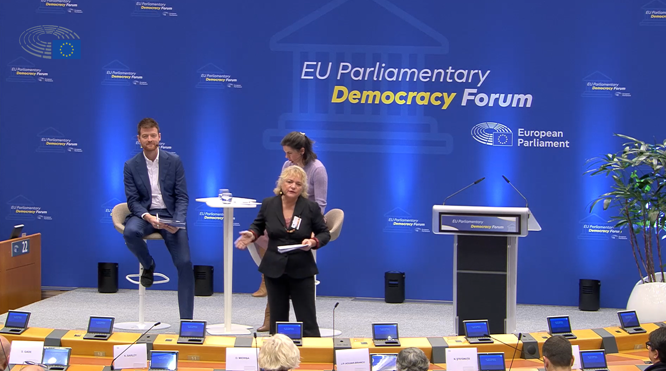
The Democratic Odyssey crew presents the vision for the institutionalisation of a permanent and transnational citizens’ assembly in Brussels

Principles:
● Distributed and translocal governance
If the governance of a transnational assembly is in part decentralised and multi-sited to reflect its cross-border nature, its institutionalisation and political buy-in can follow the same pattern. Shared governance prevents political capture and strengthens legitimacy across countries.
● Radical transparency and institutional trust
In the absence of formal authority and given the complexity of a translocal model, transparency becomes the primary source of institutional trust. Open decision-making, budgeting, and documentation signal fairness and strengthen multi-country credibility.
● Strategic alliances and critical mass

No single actor can achieve institutionalisation alone especially in a transnational context. Political buy-in requires alliances with intergovernmental bodies, civil society networks, city coalitions, and media actors - creating a “critical mass” that institutions cannot ignore.

”If it's not the European Parliament, let's go to the Council of Europe... We need to find friends." Constituent Network member, Democratic Odyssey

● Citizen-driven political mandates

Institutionalisation is best served as a democratic claim originating from citizens - not just experts or organisers. Hard-wired citizen mandates exert formal political pressure and shift the balance toward institutional recognition. A flexible mandate acknowledges the dynamic nature of deliberation as both learning and the broader context evolve during the life of the assembly.

● Permanent translocal peoples’ assembly architecture
Long-term institutionalisation requires a stable structure: a recurrent, itinerant assembly recognised by intergovernmental institutions, with rotating host cities and shared governance.

● Formal liaison and follow-up mechanisms
Political buy-in requires structured channels for receiving, evaluating, and responding to recommendations. Follow-up turns deliberation into influence.

● Local anchoring and transnational connectivity

Institutionalisation grows when assemblies leave a democratic footprint in each host city and build long-term connections between the local and the transnational levels.

● Sustainable Funding, Advocacy Capacity, and Legal Recognition
Durable institutionalisation requires stable funding, professional advocacy, and a long-term legal basis enabling transnational deliberative mandates.
Tools:
● Provide a concise multilingual mandate document outlining scope and influence pathways.
● Communicate how recommendations will be transmitted to EU, national, and local institutions.
● Include an “adaptive governance clause” allowing mandate adjustments during the cycle.
● Use pre-assembly briefings to ensure shared understanding of expectations and limits
● Establish rotating governance committees representing successive host cities.
● Include civic actors, municipalities, and academic partners in governance roles.
● Combine citizen mobilisation with civil society advocacy to create legal obligations for institutional response.
● Support alumni networks to advocate collectively for institutional reforms.
● Establish a Citizens’ Assembly Liaison Unit inside EU institutions.
● Create municipal and regional partnerships for hosting and follow-up activities.
● Support local democratic legacies: youth councils, local charters, thematic assemblies.

15 – Elected Representatives and Accountability
These guidelines are premised on the belief that a transnational assembly ought to be complementary to electoral democracy and in dialogue with political representatives. It can provide continuity and legislative legitimacy, while the decentralised deliberative process can enrich long-term thinking and experimental capacity. This prospective convergence calls for a key role for elected representatives in the assembly process as initiators of institutional follow-up procedures and as actors welcoming the accountability mechanisms offered by the Assembly. Elected representatives will hopefully join with an honest curiosity and willingness to avoid citizen-washing. They should offer an infrastructure to create synergies between civil servants, elected officials and Assembly members and create solidarity networks to accompany and strengthen the assembly.

Principles:
● Design permanent and structured transnational dialogues between citizens and representatives

Accountability of political and bureaucratic institutions improves when elected representatives and citizens meet regularly in structured, transparent dialogue - not as symbolic gestures but as part of an ongoing democratic relationship. This is both more difficult and more necessary in transnational context, where visibility and procedural obligation may vary across countries. Greater accountability in one country can be leveraged for accountability in another.

● Deliberative Literacy for Elected Representatives
Elected representatives often lack training in deliberative practice. Strengthening their understanding of citizen engagement increases the quality of interaction and accountability. Policy recommendations (i.e. one of the possible outputs) gain greater political value when institutions commit to respond clearly, publicly, and within a defined timeframe.

● Multi-actor implementation

Go beyond a traditional focus on institutional accountability and imagine a transnational, intersectoral eco-system of monitoring across countries, where there is a shared framework of mutual duties that enhances trust and clarity. Representatives, institutions, facilitators, and assembly members should agree on clear principles governing interaction and follow-up, ensuring charter-based commitments to reciprocal accountability.

● Public, Visible, and Meaningful Accountability Rituals
Plan for public rituals of accountability - where representatives report back to citizens, creating democratic visibility and reinforcing a culture of responsibility.

● Embedding Accountability Norms in Laws and Procedures
Long-term accountability requires embedding deliberative follow-up into parliamentary and institutional rules. Soft-law and procedural reforms can institutionalise the expectation of response.

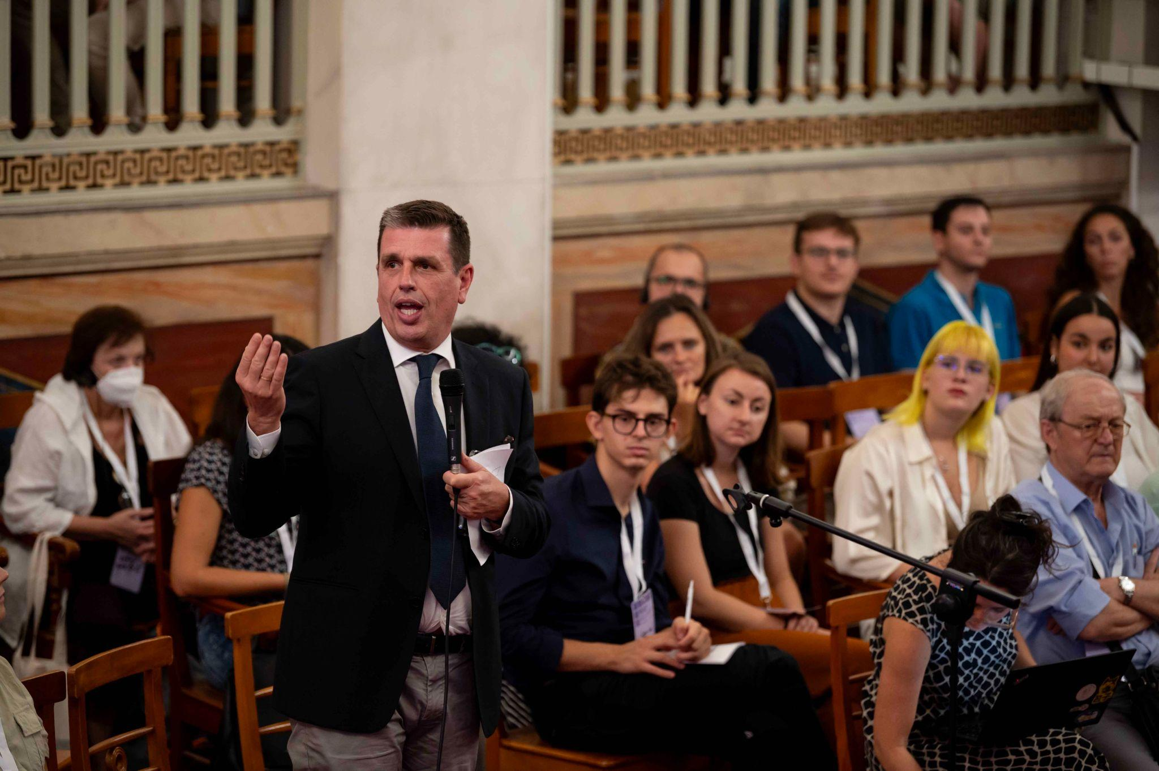
Local institutions welcome the Democratic Odyssey assembly members in Athens
Tools
● Create permanent citizens–parliament fora at EU, national, and municipal levels, convened after each assembly cycle to review recommendations and next steps.
● Ensure participation from multiple political families to guarantee a pluralistic convergence towards follow-up.
● Create public dashboards that track progress on each recommendation.
● Assign cross-party observer roles for MEPs and national parliamentarians.
● Feed outputs into key parliamentary committees
● Encourage rapporteurs to reference assembly findings in explanatory memoranda.
● Organise annual or biannual public report-back events.
● Use soft-law tools (guidelines, working procedures) to institutionalise accountability.

